Programming Graphical User Interface (GUI)

There are two sets of Java APIs for graphics programming: AWT (Abstract Windowing Toolkit) and Swing.

1. AWT API : JDK 1.0.
2. Swing API: more comprehensive, JDK 1.2.

#### AWT Packages

1. The java.awt package contains the *core* AWT graphics classes:
   * GUI Component classes (such as Button, TextField, and Label),
   * GUI Container classes (such as Frame, Panel, Dialog and ScrollPane),
   * Layout managers (such as FlowLayout, BorderLayout and GridLayout),
   * Custom graphics classes (such as Graphics, Color and Font).
2. The java.awt.event package supports event handling:
   * Event classes (such as ActionEvent, MouseEvent, KeyEvent and WindowEvent),
   * Event Listener Interfaces (such as ActionListener, MouseListener, KeyListener and WindowListener),
   * Event Listener Adapter classes (such as MouseAdapter, KeyAdapter, and WindowAdapter).

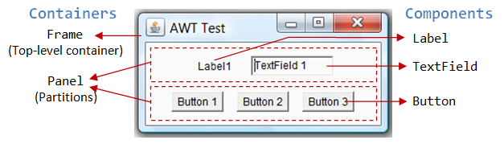**There are two types of GUI elements:**

1. ***Component*: Components are elementary GUI entities (such as Button, Label, and TextField.)**

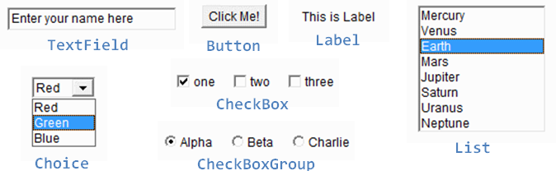

1. ***Container*: Containers (such asFrame, Panel and Applet) are used to *hold components in a specific layout* (such as flow or grid). A container can also hold sub-containers.**

##### Top-Level Containers: Frame, Dialog and Applet

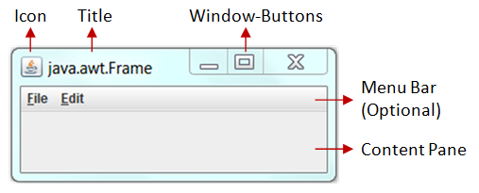

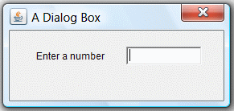

An AWT Applet (in package java.applet) is the top-level container for an applet, which is a Java program running inside a browser.

##### Secondary Containers: Panel and ScrollPane

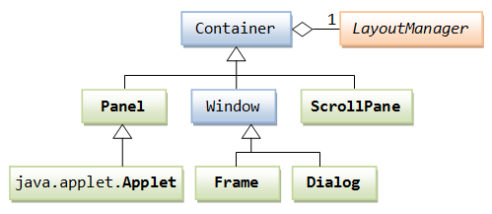

##### Constructing a Component and Adding the Component into a Container

Three steps are necessary to create and place a GUI component:

1. Declare the component with an identifier (name);
2. Construct the component by invoking an appropriate constructor via the new operator;
3. Identify the container (such as Frame or Panel) designed to hold this component. The container can then add this component onto itself via aContainer.add(aComponent) method. Every container has a add(Component) method. Take note that it is the container that actively and explicitly adds a component onto itself, instead of the other way.

<http://www3.ntu.edu.sg/home/ehchua/programming/java/J4a_GUI.html>

<http://tiger.armstrong.edu/selftest/selftest9e?chapter=13>